**MODULE-2 ACA**

**Hardware Technologies 1: Processors and Memory Hierarchy, Advanced Processor Technology, Superscalar and Vector Processors, Memory Hierarchy Technology, Virtual Memory Technology. For all Algorithms or mechanisms any one example is sufficient.**

1. **Explain with diagram RISC & CISC OR Explain The difference ? ✅ Ans in 5th page**
2. **Explain VLIW architecture With Its Instruction Pipelining? ✅ Ans is in 14th oage**
3. **Explain different Virtual memory models? ✅ Ans is in 22th page**
4. **Explain Memory Hierarchy Technology? ✅ Ans in 17th page**
5. **Explain Inclusion, Coherence, and Locality**? **✅ Ans is in 20th page**

# **4.1 Advanced Processor Technology**

## 4.1.1 Design Space of Processors

* Processors can be ―mapped to a space that has clock rate and cycles per instruction (CPI) as coordinates. Each processor type occupies a region of this space.
* Newer technologies are enabling higher clock rates.
* Manufacturers are also trying to lower the number of cycles per instruction.
* 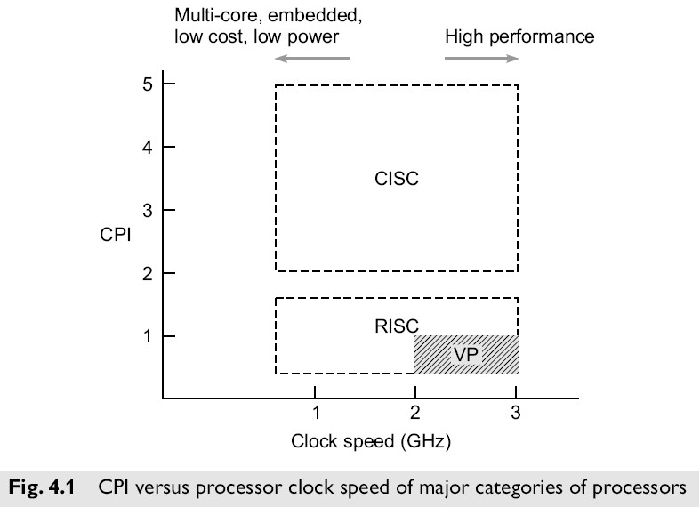Thus the ―future processor space is moving toward the lower right of the processor design space.

# 

## CISC and RISC Processors

* Complex Instruction Set Computing (CISC) processors like the Intel 80486, the Motorola 68040, the VAX/8600, and the IBM S/390 typically use microprogrammed control units, have lower clock rates, and higher CPI figures than…
* Reduced Instruction Set Computing (RISC) processors like the Intel i860, SPARC, MIPS R3000, and IBM RS/6000, which have hard-wired control units, higher clock rates, and lower CPI figures.

## Superscalar Processors

* This subclass of the RISC processors allow multiple instructions to be issued simultaneously during each cycle.
* The effective CPI of a superscalar processor should be less than that of a generic scalar RISC processor.
* Clock rates of scalar RISC and superscalar RISC machines are similar.

## VLIW Machines

* Very Long Instruction Word machines typically have many more functional units than superscalars (and thus the need for longer – 256 to 1024 bits – instructions to provide control for them).
* These machines mostly use microprogrammed control units with relatively slow clock rates because of the need to use ROM to hold the microcode.

## Superpipelined Processors

* These processors typically use a multiphase clock (actually several clocks that are out of phase with each other, each phase perhaps controlling the issue of another instruction) running at a relatively high rate.
* The CPI in these machines tends to be relatively high (unless multiple instruction issue is used).
* Processors in vector supercomputers are mostly superpipelined and use multiple functional units

for concurrent scalar and vector operations.

## Instruction Pipelines

* Typical instruction includes four phases:
  + fetch
  + decode
  + execute
  + write-back
* These four phases are frequently performed in a pipeline, or ―assembly line‖ manner, as illustrated on the figure 4.2.
* The pipeline, like an industrial assembly line, receives successive instructions from its input end and executes them in a streamlined, overlapped fashion as they flow through.
* A pipeline cycle is intuitively defined as the time required for each phase to complete its opetion, assuming equal delay in all phases (pipeline stages).

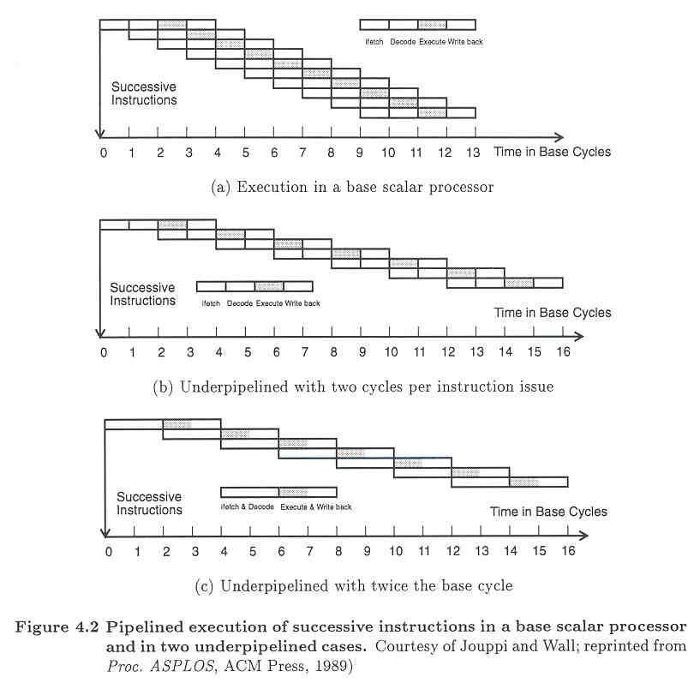

Basic definitions associated with Pipeline operations:

* **Instruction pipeline cycle** – the time required for each phase to complete its operation (assuming equal delay in all phases)
* **Instruction issue latency** – the time (in cycles) required between the issuing of two adjacent instructions
* **Instruction issue rate** – the number of instructions issued per cycle (the *degree* of a superscalar)
* **Simple operation latency** – the delay (after the previous instruction) associated with the completion of a simple operation (e.g. integer add) as compared with that of a complex operation (e.g. divide).
* **Resource conflicts** – when two or more instructions demand use of the same functional unit(s) at the same time.

### Pipelined Processors

* **A *base scalar processor***:
  + issues one instruction per cycle
  + has a one-cycle latency for a simple operation
  + has a one-cycle latency between instruction issues
  + can be fully utilized if instructions can enter the pipeline at a rate on one per cycle
* For a variety of reasons, instructions might not be able to be pipelines as aggressively as in a base scalar processor. In these cases, we say the pipeline is *underpipelined*.
* CPI rating is 1 for an ideal pipeline. Underpipelined systems will have higher CPI ratings, lower clock rates, or both.

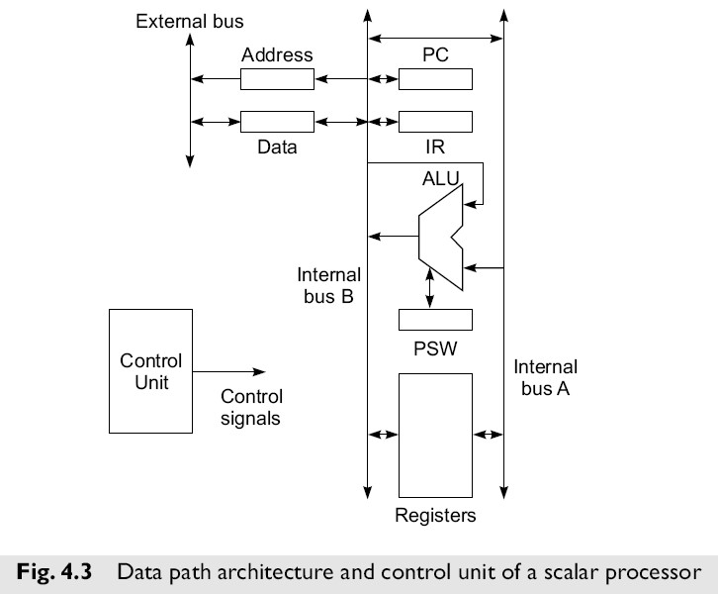

* Figure 4.3 shows the data path architecture and control unit of a typical, simple scalar processor which does not employ an instruction pipeline. Main memory, I/O controllers, etc. are connected to the external bus.
* The control unit generates control signals required for the *fetch, decode*, *ALU operation*, *memory access*, and *write result* phases of instruction execution.
* The control unit itself may employ hardwired logic, or—as was more common in older CISC style processors—microcoded logic.
* Modern RISC processors employ hardwired logic, and even modern CISC processors make use of many of the techniques originally developed for high-performance RISC processors.

**4.1.2 Instruction Set Architectures**

* **CISC** 
  + Many different instructions
  + Many different operand data types
  + Many different operand addressing formats
  + Relatively small number of general purpose registers
  + Many instructions directly match high-level language constructions
* **RISC** 
  + Many fewer instructions than CISC (freeing chip space for more functional units!)
  + Fixed instruction format (e.g. 32 bits) and simple operand addressing
  + Relatively large number of registers
  + Small CPI (close to 1) and high clock rates

#### Architectural Distinctions

* **CISC** 
  + Unified cache for instructions and data (in most cases)
  + Microprogrammed control units and ROM in earlier processors (hard-wired controls units now in some CISC systems)
* **RISC** 
  + Separate instruction and data caches – Hard-wired control units

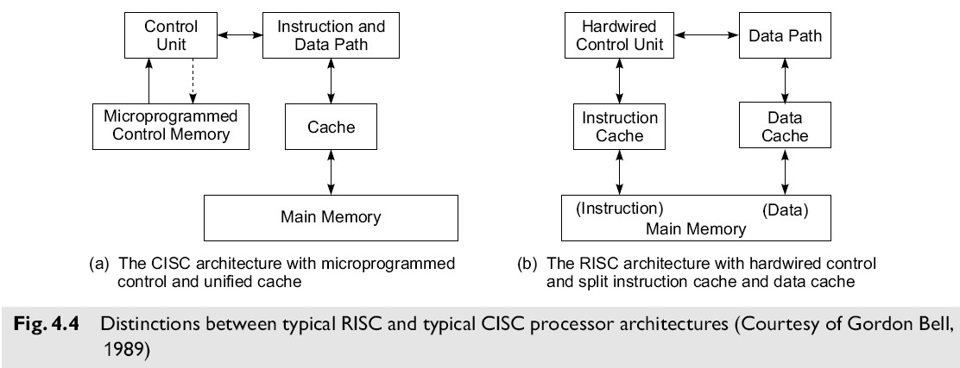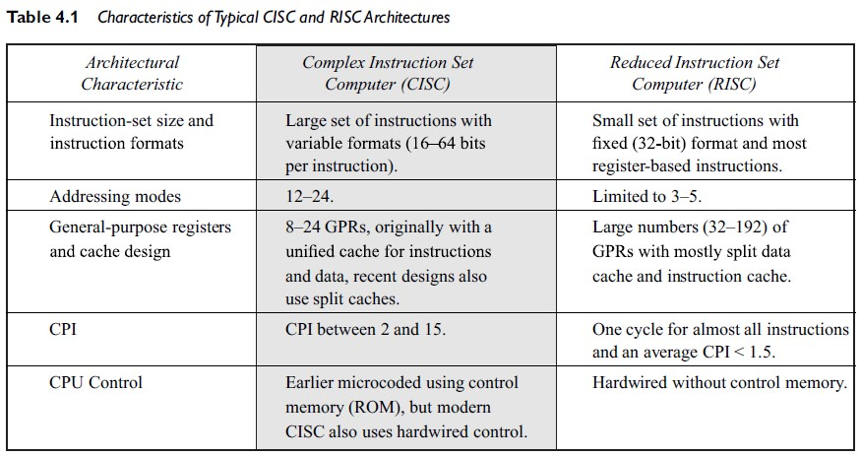

* **CISC Advantages**

– Smaller program size (fewer instructions)

* + Simpler control unit design
  + Simpler compiler design
* **RISC Advantages** 
  + Has potential to be faster
  + Many more registers
* **RISC Problems** 
  + More complicated register decoding system
  + Hardwired control is less flexible than microcode

##### 4.1.3 CISC Scalar Processors

* Early systems had only integer fixed point facilities.
* Modern machines have both fixed and floating point facilities, sometimes as parallel functional units.
* Many CISC scalar machines are underpipelined.

**Representative CISC Processors:**

* + VAX 8600
  + Motorola MC68040
  + Intel Pentium

#### VAX 8600 processor

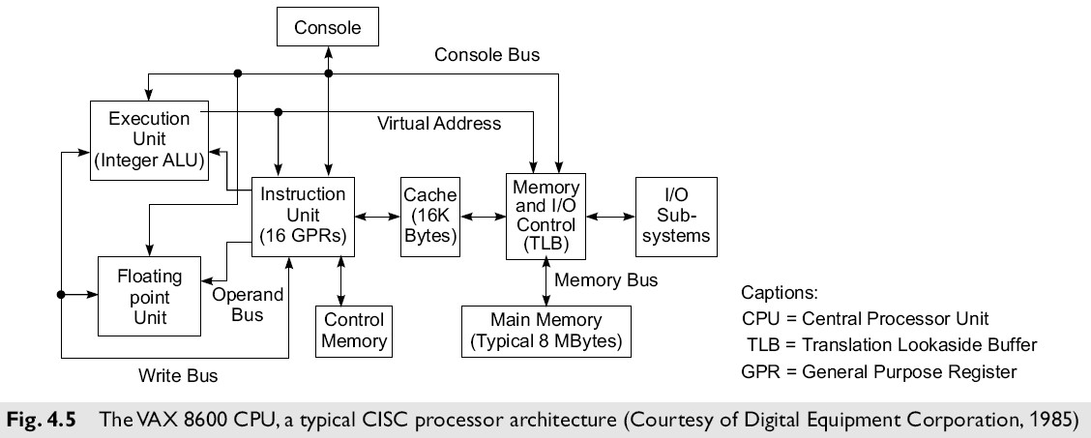

* The VAX 8600 was introduced by Digital Equipment Corporation in 1985.
* This machine implemented a typical CISC architecture with microprogrammed control.
* The instruction set contained about 300 instructions with 20 different addressing modes. integer and floating point instructions.
* The CPU in the VAX 8600 consisted of two functional units for concurrent execution of
* The unified cache was used for holding both instructions and data.
* There were 16 GPRs in the instruction unit. Instruction pipelining was built with six stages in the VAX 8600, as in most elsc machines.
* The instruction unit prefetched and decoded instructions, handled branching operations, and supplied operands to the two functional units in a pipelined fashion.
* A Translation Lookaside Buffer (TLB) was used in the memory control unit for fast generation of a physical address from a virtual address.
* Both integer and floating point units were pipelined.
* The performance of the processor pipelines relied heavily on the cache hit ratio and on minimal branching damage to the pipeline flow.

##### 4.1.4 RISC Scalar Processors

* Designed to issue one instruction per cycle
* RISC and CISC scalar processors should have same performance if clock rate and program lengths are equal.
* RISC moves less frequent operations into software, thus dedicating hardware resources to the most frequently used operations.

**Representative RISC Processors:**

* + Sun SPARC
  + Intel i860
  + Motorola M88100
  + AMD 29000

#### SPARCs (Scalable Processor Architecture) and Register Windows

* SPARC family chips produced by Cypress Semiconductors, Inc. Figure 4.7 shows the architecture of the Cypress CY7C601 SPARC processor and of the CY7C602 FPU.
* The Sun SPARC instruction set contains 69 basic instructions
* The SPARC runs each procedure with a set of thirty-two 32-bit IU registers.
* Eight of these registers are ***global registers***shared by all procedures, and the remaining 24 are ***window registers*** associated with only each procedure.
* The concept of using overlapped register windows is the most important feature introduced by the Berkeley RISC architecture.

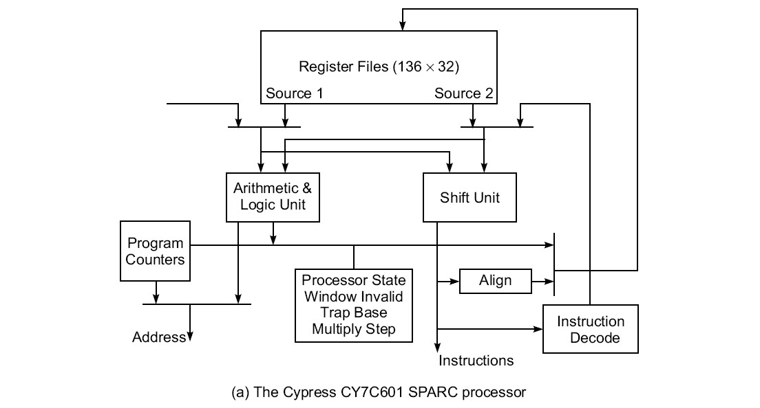

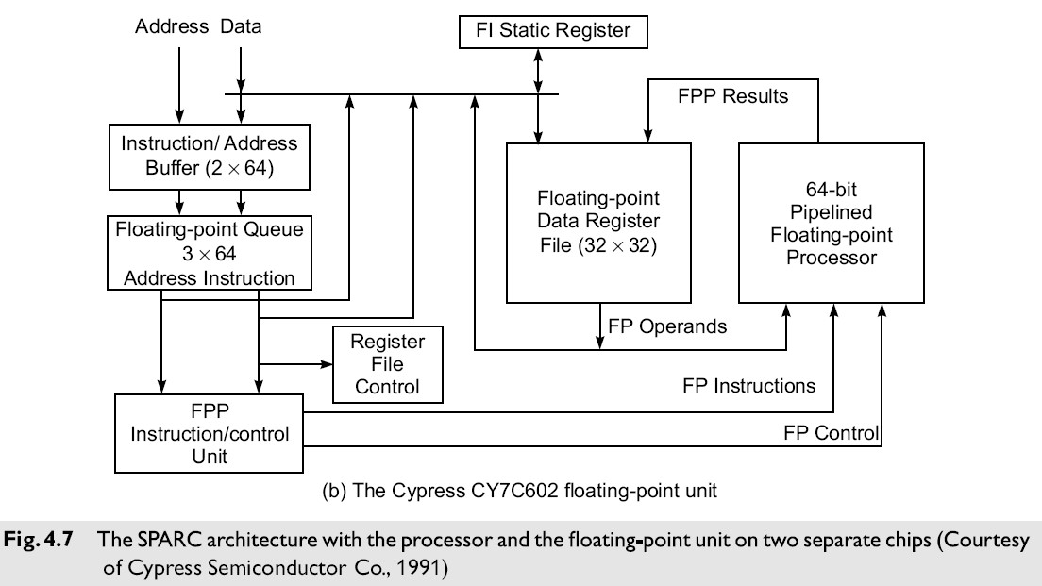

## 4.2 Superscalar, Vector Processors

* A CISC or a RISC scalar processor can be improved with a superscalar or vector architecture.
* Scalar processors are those executing one instruction per cycle.
* Only one instruction is issued per cycle, and only one completion of instruction is expected from the pipeline per cycle.
* In a superscalar processor, multiple instructions are issued per cycle and multiple results are generated per cycle.
* A vector processor executes vector instructions on arrays of data; each vector instruction involves a string of repeated operations, which are ideal for pipelining with one result per cycle.

**4.2.1 Superscalar Processors**

* Superscalar processors are designed to exploit more instruction-level parallelism in user programs.
* Only independent instructions can be executed in parallel without causing a wait state. The amount of instruction level parallelism varies widely depending on the type of code being executed.
* It has been observed that the average value is around 2 for code without loop unrolling. Therefore, for these codes there is not much benefit gained from building a machine that can issue more than three instructions per cycle.
* The instruction-issue degree in a superscalar processor has thus been limited to 2 to 5 in practice.

### Pipelining in Superscalar Processors

* The fundamental structure of a three-issue superscalar pipeline is illustrated in Fig. 4.11.
* Superscalar processors were originally developed as an alternative to vector processors, with a view to exploit higher degree of instruction level parallelism.

# 

* A superscalar processor of degree m can issue m instructions per cycle.
* The base scalar processor, implemented either in RISC or CISC, has m = 1.
* In order to fully utilize a superscalar processor of degree m, m instructions must be executable in parallel. This situation may not be true in all clock cycles.
* In that case, some of the pipelines may be stalling in a wait state.
* In a superscalar processor, the simple operation latency should require only one cycle, as in the base scalar processor.
* Due to the desire for a higher degree of instruction-level parallelism in programs, the superscalar processor depends more on an optimizing compiler to exploit parallelism.

## Representative Superscalar Processors

VTUPulse.com

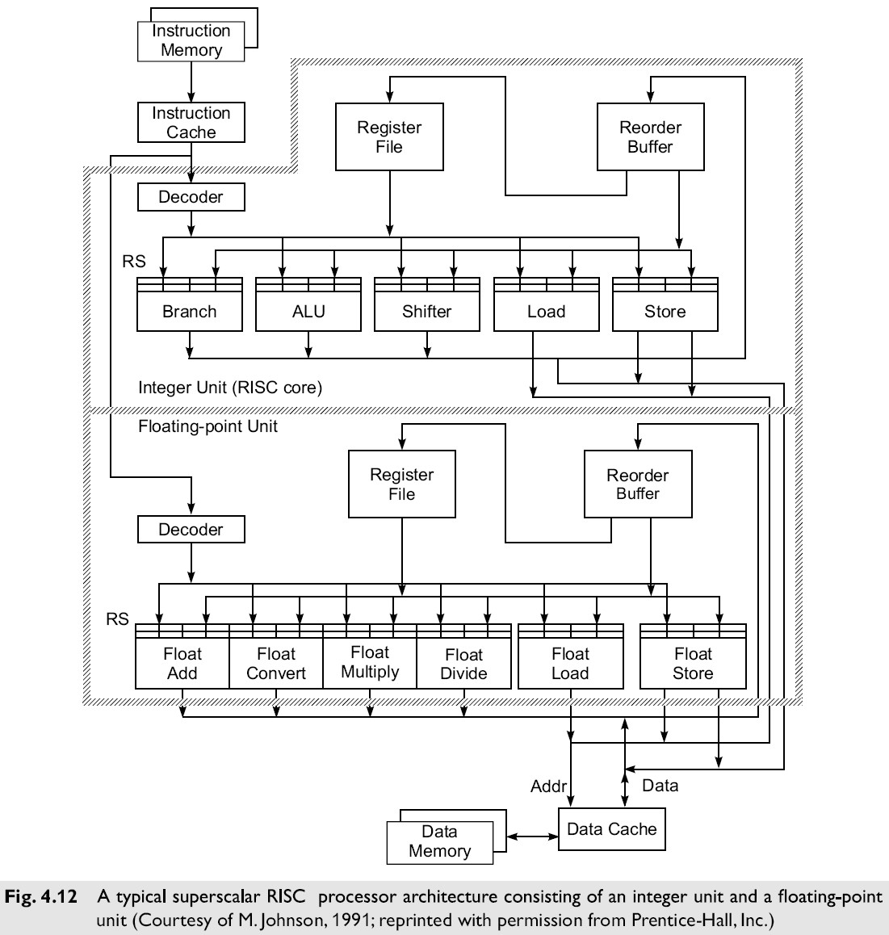

Typical Superscalar Architecture

* A typical superscalar will have
  + multiple instruction pipelines
  + an instruction cache that can provide multiple instructions per fetch
  + multiple buses among the function units
* In theory, all functional units can be simultaneously active.

### 4.2.2 VLIW Architecture

* VLIW = Very Long Instruction Word
* Instructions usually hundreds of bits long.
* Each instruction word essentially carries multiple ―short instructions.‖
* Each of the ―short instructions‖ are effectively issued at the same time.
* (This is related to the long words frequently used in microcode.)
* Compilers for VLIW architectures should optimally try to predict branch outcomes to properly group instructions.

## Pipelining in VLIW Processors

* Decoding of instructions is easier in VLIW than in superscalars, because each ―region‖ of an instruction word is usually limited as to the type of instruction it can contain.
* Code density in VLIW is less than in superscalars, because if a ―region‖ of a VLIW word isn’t needed in a particular instruction, it must still exist (to be filled with a ―no op‖).
* Superscalars can be compatible with scalar processors; this is difficult with VLIW parallel and

non-parallel architectures.

# 

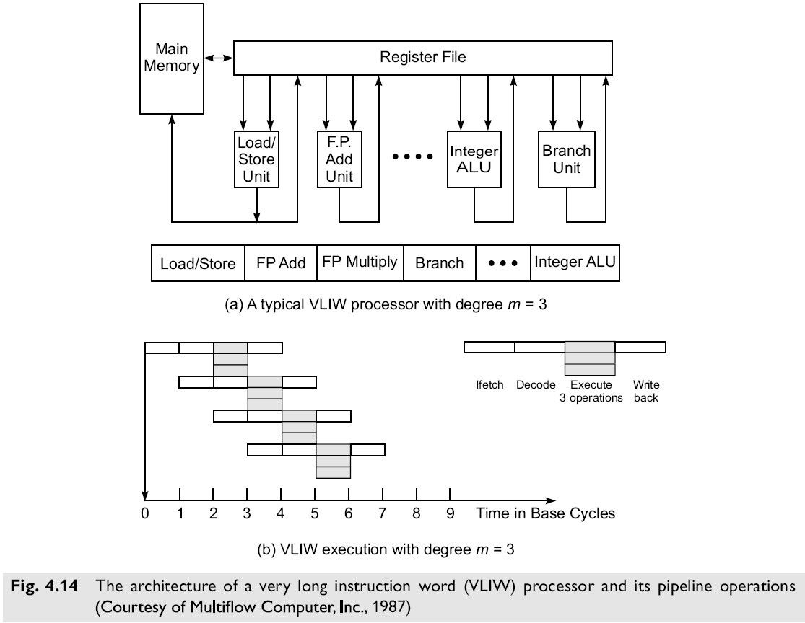

## VLIW Opportunities

* ―Random‖ parallelism among scalar operations is exploited in VLIW, instead of regular parallelism in a vector or SIMD machine.
* The efficiency of the machine is entirely dictated by the success, or ―goodness,‖ of the compiler in planning the operations to be placed in the same instruction words.
* Different implementations of the same VLIW architecture may not be binary-compatible with each other, resulting in different latencies.

## VLIW Summary

* VLIW reduces the effort required to detect parallelism using hardware or software techniques.
* The main advantage of VLIW architecture is its simplicity in hardware structure and instruction set.
* Unfortunately, VLIW does require careful analysis of code in order to ―compact‖ the most appropriate ‖short‖ instructions into a VLIW word.

## 4.2.3 Vector Processors

* A vector processor is a coprocessor designed to perform vector computations.
* A vector is a one-dimensional array of data items (each of the same data type).
* Vector processors are often used in multipipelined supercomputers.

Architectural types include:

* 1. **Register-to-Register** (with shorter instructions and register files)
  2. **Memory-to-Memory** (longer instructions with memory addresses)

### 1. Register-to-Register Vector Instructions

* Assume Vi is a vector register of length n, si is a scalar register, M(1:n) is a memory array of length n, and ―ο‖ is a vector operation.
* Typical instructions include the following: 
  + **V1 ο V2**  **V3** (element by element operation)
  + **s1 ο V1**  **V2** (scaling of each element)
  + **V1 ο V2**  **s1** (binary reduction - i.e. sum of products)
  + **M(1:n)**  **V1** (load a vector register from memory)
  + **V1**  **M(1:n)** (store a vector register into memory)
  + **ο V1**  **V2** (unary vector -- i.e. negation)
  + **ο V1**  **s1** (unary reduction -- i.e. sum of vector)

### 2. Memory-to-Memory Vector Instructions

• Typical memory-to-memory vector instructions (using the same notation as given in the previous slide) include these:

* **M1(1:n) ο M2(1:n)**  **M3(1: n)** (binary vector)
* **s1 ο M1(1:n)**  **M2(1:n)** (scaling)
* **ο M1(1:n)**  **M2(1:n)**  (unary vector)
* **M1(1:n) ο M2(1:n)**  **M(k)** (binary reduction)

### Symbolic Processors

* Symbolic processors are somewhat unique in that their architectures are tailored toward the execution of programs in languages similar to LISP, Scheme, and Prolog.
* In effect, the hardware provides a facility for the manipulation of the relevant data objects with ―tailored‖ instructions.
* These processors (and programs of these types) may invalidate assumptions made about more traditional scientific and business computations.

## 4.3 Memory Hierarchical Technology

* Storage devices such as registers, caches, main memory, disk devices, and backup storage are often organized as a hierarchy as depicted in Fig. 4.17.
* The memory technology and storage organization at each level is characterized by five parameters:
  1. **access time ti** (round-trip time from CPU to ith level)
  2. **memory size si** (number of bytes or words in level i)
  3. **cost per byte ci**
  4. **transfer bandwidth bi** (rate of transfer between levels)
  5. **unit of transfer xi** (grain size for transfers between levels i and i+1)

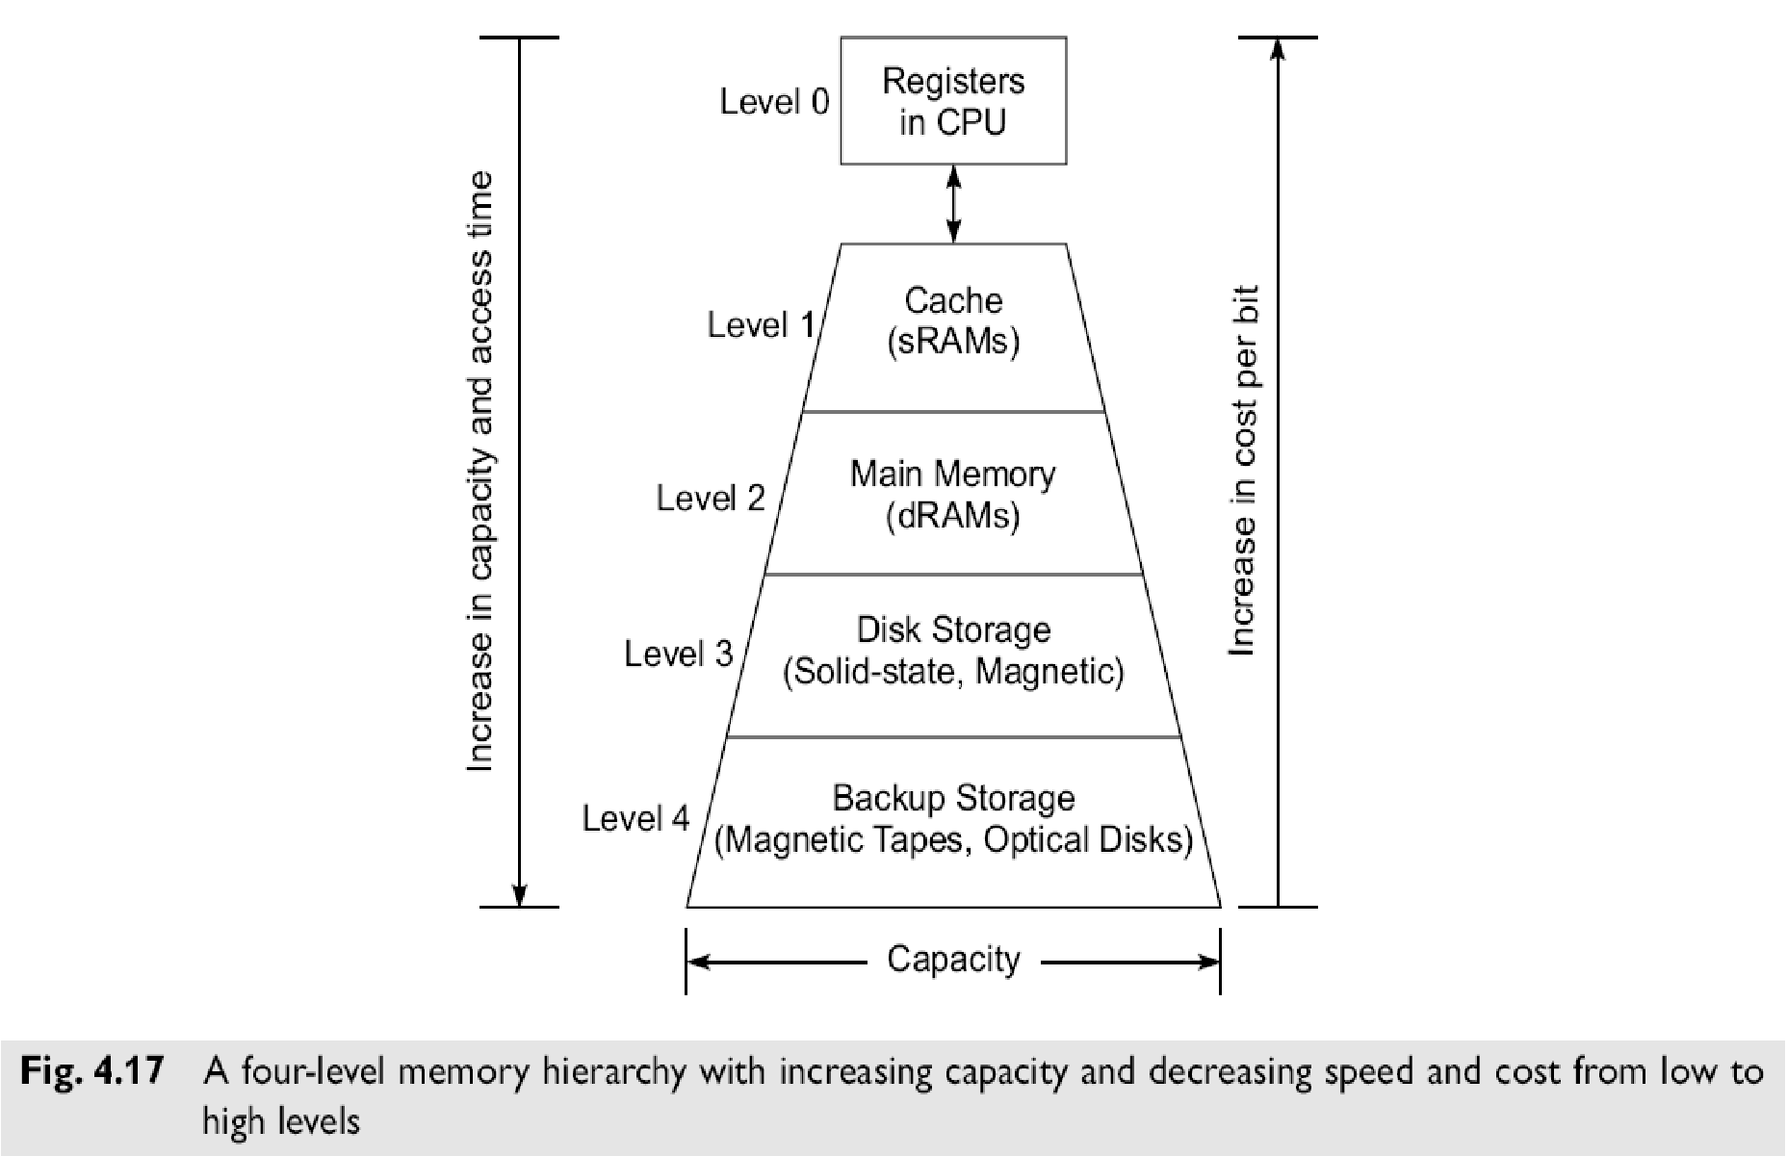

Memory devices at a lower level are:

• faster to access,

* are smaller in capacity,
* are more expensive per byte,
* have a higher bandwidth, and
* have a smaller unit of transfer.

In general, **ti-1 < ti, si-1 < si, ci-1 > ci, bi-1 > bi and xi-1 < xi** for i = 1, 2, 3, and 4 in the hierarchy where i = 0 corresponds to the CPU register level.

The cache is at level 1, main memory at level 2, the disks at level 3 and backup storage at level 4.

### Registers and Caches

**Registers**

* The registers are parts of the processor;
* Register assignment is made by the compiler.
* Register transfer operations are directly controlled by the processor after instructions are decoded.
* Register transfer is conducted at processor speed, in one clock cycle.

**Caches**

* The cache is controlled by the MMU and is programmer-transparent.
* The cache can also be implemented at one or multiple levels, depending on the speed and application requirements.
* Multi-level caches are built either on the processor chip or on the processor board.
* Multi-level cache systems have become essential to deal with memory access latency.

**Main Memory** **(**Primary Memory**)**

* It is usually much larger than the cache and often implemented by the most cost-effective RAM chips, such as DDR SDRAMs, i.e. dual data rate synchronous dynamic RAMs.
* The main memory is managed by a MMU in cooperation with the operating system.

### Disk Drives and Backup Storage

* The disk storage is considered the highest level of on-line memory.
* It holds the system programs such as the OS and compilers, and user programs and their data sets.
* Optical disks and magnetic tape units are off-line memory for use as archival and backup storage. • They hold copies of present and past user programs and processed results and files.
* Disk drives are also available in the form of RAID arrays.

### Peripheral Technology

* Peripheral devices include printers, plotters, terminals, monitors, graphics displays, optical scanners, image digitizers, output microfilm devices etc.
* Some I/O devices are tied to special-purpose or multimedia applications.

### 4.3.2 Inclusion, Coherence, and Locality

Information stored in a memory hierarchy (M1, M2,…, Mn) satisfies 3 important properties:

1. **Inclusion**
2. **Coherence**
3. **Locality**

* We consider cache memory the innermost level M1, which directly communicates with the CPU registers.
* The outermost level Mn contains all the information words stored. In fact, the collection of all addressable words in Mn forms the virtual address space of a computer.
* Program and data locality is characterized below as the foundation for using a memory hierarchy effectively.

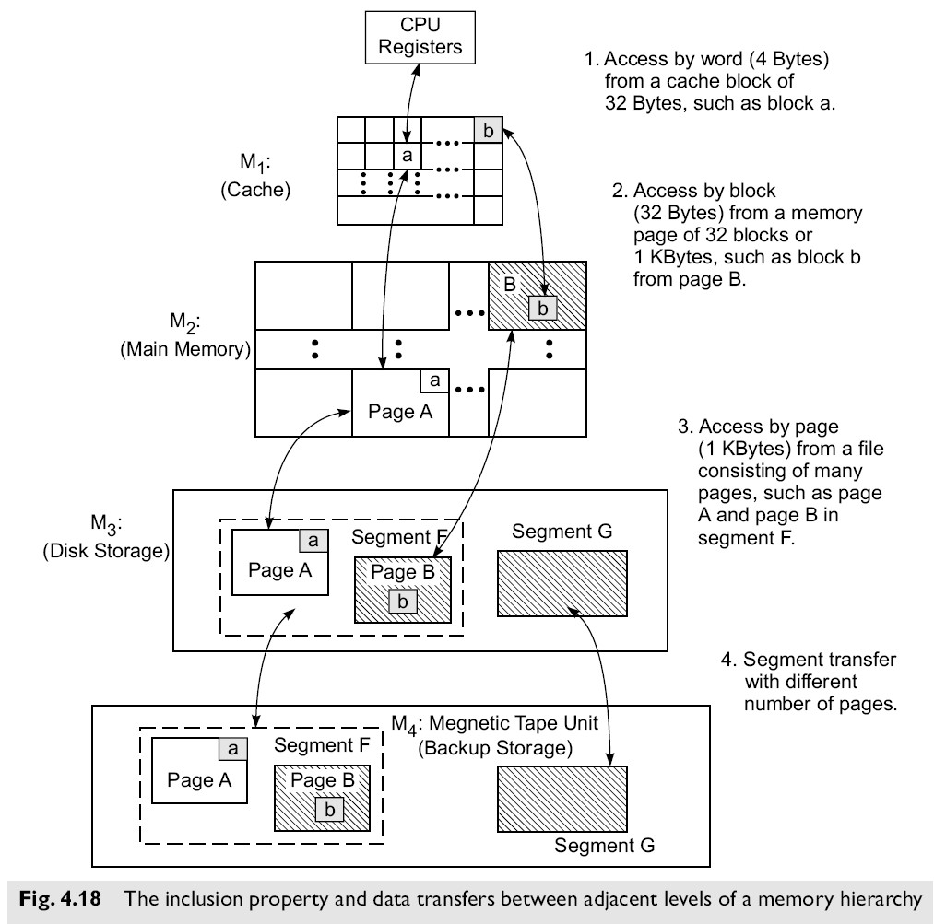

#### 1. The Inclusion Property

* The inclusion property is stated as:

**M1**  **M2**  **...**  **Mn**

* The implication of the inclusion property is that all items of information in the ―innermost‖ memory level (cache) also appear in the outer memory levels.
* The inverse, however, is not necessarily true. That is, the presence of a data item in level Mi+1 does not imply its presence in level Mi. We call a reference to a missing item a ―miss.‖

#### 2. The Coherence Property

The requirement that copies of data items at successive memory levels be **consistent** is called the ―coherence property.‖

#### Coherence Strategies

* **Write-through** 
  + As soon as a data item in Mi is modified, immediate update of the corresponding data item(s) in Mi+1, Mi+2, … Mn is required.
  + This is the most aggressive (and expensive) strategy.
* **Write-back** 
  + The update of the data item in Mi+1 corresponding to a modified item in Mi is not updated unit it (or the block/page/etc. in Mi that contains it) is replaced or removed.

– This is the most efficient approach, but cannot be used (without modification) when

multiple processors share Mi+1, …, Mn.

##### 3. Locality of References

* Memory references are generated by the CPU for either instruction or data access.
* These accesses tend to be clustered in certain regions in time, space, and ordering.

There are three dimensions of the locality property:

* + ***Temporal locality*** – if location M is referenced at time t, then it (location M) will be referenced again at some time **t+****t**.
  + ***Spatial locality*** – if location M is referenced at time t, then another location Mm will be referenced at time **t+****t**.
  + ***Sequential locality*** – if location **M** is referenced at time  **t**, then locations **M+1, M+2, …** will be referenced at time **t+****t**, **t+****t’**, etc.
* In each of these patterns, both m and t are ―small.‖
* H&P suggest that 90 percent of the execution time in most programs is spent executing only 10 percent of the code.

## 4.4 Virtual Memory Technology

* To facilitate the use of memory hierarchies, the memory addresses normally generated by modern processors executing application programs are not *physical addresses*, but are rather *virtual addresses* of data items and instructions.
* Physical addresses, of course, are used to reference the available locations in the real physical memory of a system.
* Virtual addresses must be mapped to physical addresses before they can be used.
* 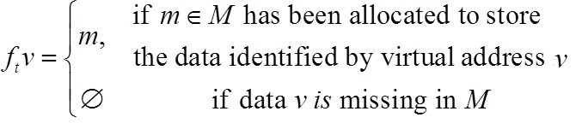 The mapping from virtual to physical addresses can be formally defined as follows: **Virtual to Physical Mapping**

* The mapping returns a physical address if a *memory hit* occurs. If there is a *memory miss*, the re
* ferenced item has not yet been brought into primary memory.

**Mapping Efficiency**

* The efficiency with which the virtual to physical mapping can be accomplished significantly

affects the performance of the system.

* Efficient implementations are more difficult in multiprocessor systems where additional problems such as coherence, protection, and consistency must be addressed.

## Virtual Memory Models

1. Private Virtual Memory
2. Shared Virtual Memory

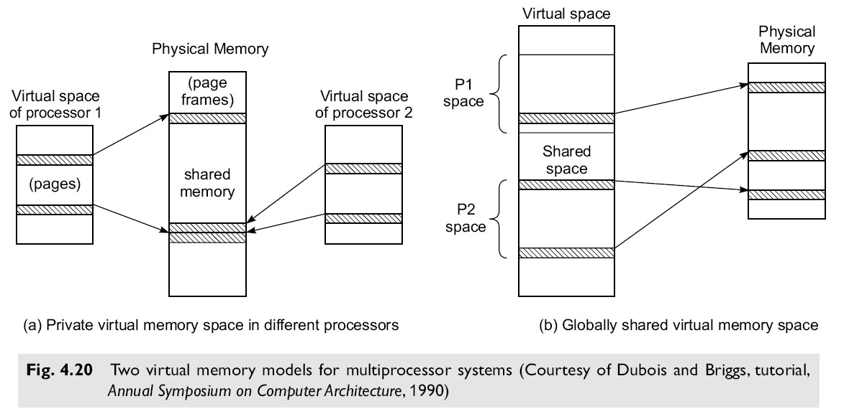

### 1. Private Virtual Memory

* In this scheme, each processor has a separate virtual address space, but all processors share the same physical address space.
* **Advantages**:

• Small processor address space

* + Protection on a per-page or per-process basis
  + Private memory maps, which require no locking

## – Disadvantages

* The synonym problem – different virtual addresses in different/same virtual spaces point to the same physical page
* The same virtual address in different virtual spaces may point to different pages in physical memory

### 2. Shared Virtual Memory

* All processors share a single shared virtual address space, with each processor being given a portion of it.
* Some of the virtual addresses can be shared by multiple processors.

**Advantages**:

* All addresses are unique
* Synonyms are not allowed

**Disadvantages**

* Processors must be capable of generating large virtual addresses (usually > 32 bits)
* Since the page table is shared, mutual exclusion must be used to guarantee atomic updates • Segmentation must be used to confine each process to its own address space
* The address translation process is slower than with private (per processor) virtual memory **Memory Allocation**

Both the virtual address space and the physical address space are divided into fixed-length pieces.

* + In the virtual address space these pieces are called ***pages***.
  + In the physical address space they are called ***page frames***.
* The purpose of memory allocation is to allocate pages of virtual memory using the page frames of physical memory.

4.4.2 TLB, Paging, and Segmentation

Both the virtual memory and physical memory are partitioned into fixed-length pages. The purpose of memory allocation is to allocate pages of virtual memory to the page frames of the physical memory.

### Address Translation Mechanisms

* The process demands the translation of virtual addresses into physical addresses. Various schemes

for virtual address translation are summarized in Fig. 4.21a.

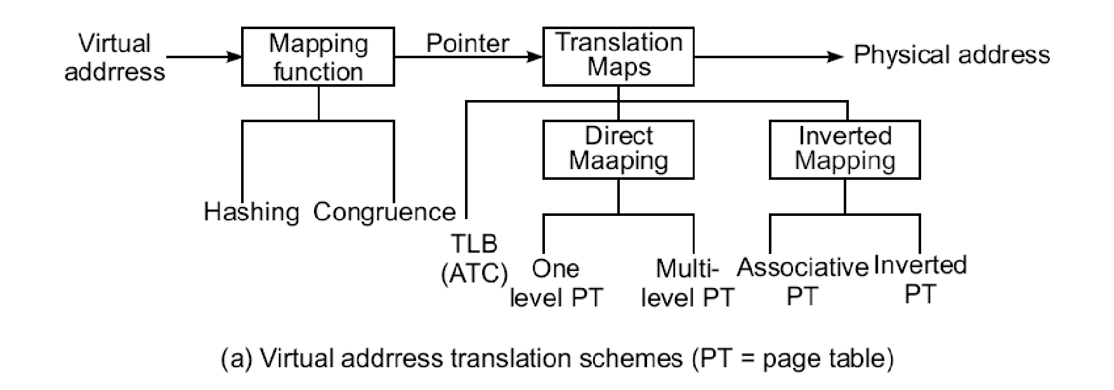

* The translation demands the use of *translation maps* which can be implemented in various ways.
* Translation maps are stored in the cache, in associative memory, or in the main memory.
* To access these maps, a mapping function is applied to the virtual address. This function generates a pointer to the desired translation map.
* This mapping can be implemented with a *hashing* or *congruence* function.
* Hashing is a simple computer technique for converting a long page number into a short one with fewer bits.
* The hashing function should randomize the virtual page number and produce a unique hashed number to be used as the pointer.

### Translation Lookaside Buffer

* The TLB is a high-speed lookup table which stores the most recently or likely referenced page entries.
* A *page entry* consists of essentially a (virtual page number, page frame number) pair. It is hoped that pages belonging to the same working set will be directly translated using the TLB entries.
* The use of a TLB and PTs for address translation is shown in Fig 4.21b. Each virtual address is divided into 3 fields:
  + The leftmost field holds the virtual page number,

– the middle field identifies the cache block number,

* + the rightmost field is the word address within the block.

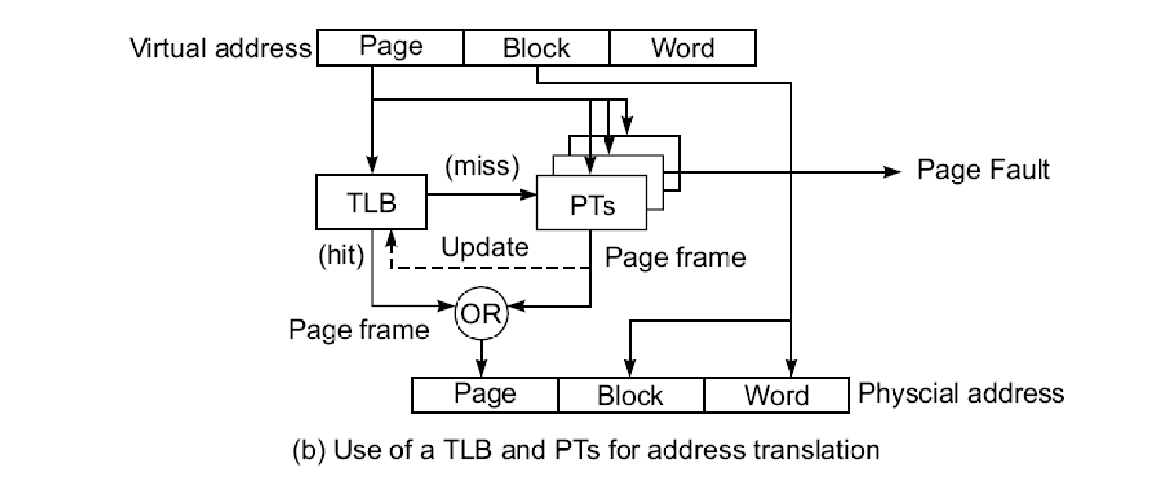

* Our purpose is to produce the physical address consisting of the page frame number, the block number, and the word address.
* The first step of the translation is to use the virtual page number as a key to search through the TLB for a match.
* The TLB can be implemented with a special associative memory (content addressable memory) or use part of the cache memory.
* In case of a match (a hit) in the TLB, the page frame number is retrieved from the matched page entry. The cache block and word address are copied directly.
* In case the match cannot be found (a miss) in the TLB, a hashed pointer is used to identify one of the page tables where the desired page frame number can be retrieved.

### Implementing Virtual Memory

There are 3 approaches to implement virtual memory:

1. Paging
2. Segmentation
3. A combination of the two called **Paged Segmentation**

#### 1. Paging memory

* Memory is divided into fixed-size blocks called pages.

virtual memory.

* Main memory contains some number of pages which is smaller than the number of pages in the
* **For example,** if the page size is 2K and the physical memory is 16M (8K pages) and the virtual memory is 4G (2 M pages) then there is a factor of 254 to 1 mapping.
* A page map table is used for implementing a mapping, with one entry per virtual page.

#### 2. Segmented memory

* In a segmented memory management system the blocks to be replaced in main memory are potentially of unequal length and here the segments correspond to logical blocks of code or data.

**For example**, a subroutine or procedure.

* Segments, then, are ``atomic'' in the sense that either the whole segment should be in main memory, or none of the segment should be there.
* The segments may be placed anywhere in main memory, but the instructions or data in one segment should be contiguous,

#### 3. Paged Segmentation

* It is a combination of paging and segmentation concepts
* Within each segment, the addresses are divided into fixed size pages
* Each virtual address is divided into 3 fields
  + Segment Number
  + Page Number
  + Offset

#### 4.4.3 Page Replacement Policies

* Memory management policies include the allocation and deallocation of memory pages to active processes and the replacement of memory pages.
* Demand paging memory systems. refers to the process in which a resident page in main memory is replaced by a new page transferred from the disk.
* Since the number of available page frames is much smaller than the number of pages, the frames
* In order to accommodate a new page, one of the resident pages must be replaced. will eventually be fully occupied.
* The goal of a page replacement policy is to minimize the number of possible page faults so that the effective memory-access time can be reduced.
* The effectiveness of a replacement algorithm depends on the program behavior and memory traffic patterns encountered.
* A good policy should match the program locality property. The policy is also affected by page size and by the number of available frames.

**Page Traces:** A *page trace* is a sequence of *page frame numbers* (PFNs) generated during the execution of a given program.

The following page replacement policies are specified in a demand paging memory system for a page fault at time *t*.

1. **Least recently used (LRU)**—This policy replaces the page in R(t) which has the longest backward distance:



1. **Optimal (OPT) algorithm**—This policy replaces the page in R(t) with the longest forward distance:



1. **First-in-first-out (FIFO)**—This policy replaces the page in R(t) which has been in memory for the longest time.
2. **Least frequently used (LFU)**—This policy replaces the page in R(t) which has been least referenced in the past.
3. **Circular FIFO**—This policy joins all the page frame entries into a circular FIFO queue using a pointer to indicate the front of the queue.

* An allocation bit is associated with each page frame. This bit is set upon initial allocation of a page to the frame.
* When a page fault occurs, the queue is circularly scanned from the pointer position.
* The pointer skips the allocated page frames and replaces the very first unallocated page frame.
* When all frames are allocated, the front of the queue is replaced, as in the FIFO policy.

# randomly.

(6) **Random replacement**—This is a trivial algorithm which chooses any page for replacement

**Example:**

Consider a paged virtual memory system with a two-level hierarchy: main memory M1 and disk memory M2.

Assume a page size of four words. The number of page frames in M 1 is 3, labeled a, b and c; and the number of pages in M2 is 10, identified by 0, 1, 2,….9. The ith page in M2consists of word addresses 4i to 4i + 3 for all i = 0, 1, 2, …, 9.

A certain program generates the following sequence of word addresses which are grouped (underlined) together if they belong to the same page. The sequence of page numbers so formed is the *page trace*:

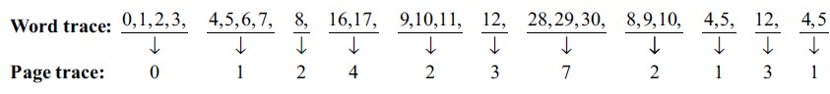

Page tracing experiments are described below for three page replacement policies: LRU, OPT, and FIFO, respectively. The successive pages loaded in the page frames (PFs) form the trace entries.

Initially, all PFs are empty.



 